Work Refusal Record Form

 | Organization: |  |  |  | Department: |  |  | Date:
 | Time of Work Refusal:
 | Supervisor: |  |  |  |  |  | Employee:
 | OHS Rep:
 | 3.12 (2) Worker reports undue hazard to Supervisor/Employer
Describe the hazard(s)

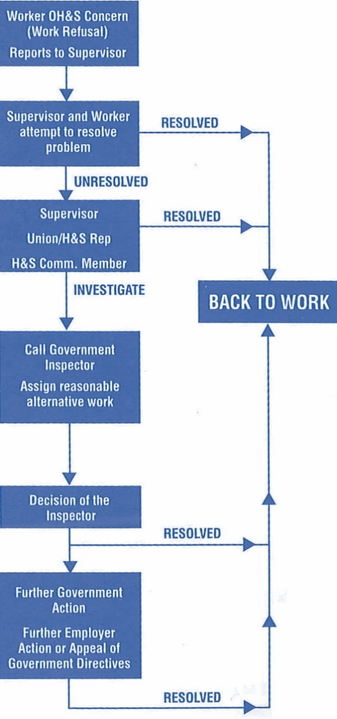

Work Refusal Record Form

3.12 Procedure for refusal
(1) A person must not carry out or cause to be carried out any work process or operate or cause to be operated any tool, appliance or equipment if that person has reasonable cause to believe that to do so would create an undue hazard to the health and safety of any person.
(2) A worker who refuses to carry out a work process or operate a tool, appliance or equipment pursuant to subsection (1) must immediately report the circumstances of the unsafe condition to his or her supervisor or employer.
(3) A supervisor or employer receiving a report made under subsection (2) must immediately investigate the matter and
(a) ensure that any unsafe condition is remedied without delay, or
(b) if in his or her opinion the report is not valid, must so inform the person who made the report.
(4) If the procedure under subsection (3) does not resolve the matter and the worker continues to refuse to carry out the work process or operate the tool, appliance or equipment, the supervisor or employer must investigate the matter in the presence of the worker who made the report and in the presence of
(a) a worker member of the joint committee,
(b) a worker who is selected by a trade union representing the worker, or
(c) if there is no joint committee or the worker is not represented by a trade union, any other reasonably available worker selected by the worker.
(5) If the investigation under subsection (4) does not resolve the matter and the worker continues to refuse to carry out the work process or operate the tool, appliance or equipment, both the supervisor, or the employer, and the worker must immediately notify an officer, who must investigate the matter without undue delay and issue whatever orders are deemed necessary.

3.13 No discriminatory action
(1) A worker must not be subject to discriminatory action as defined in section 47 of Part 2 of the Workers Compensation Act because the worker has acted in compliance with section 3.12 or with an order made by an officer.
(2) Temporary assignment to alternative work at no loss in pay to the worker until the matter in section 3.12 is resolved is deemed not to constitute discriminatory action.
G-12.2 "Undue hazard"
A "hazard" is identified in Part 1 of the Regulation as "a thing or condition that may expose a person to a risk of injury or occupational disease." Further, "undue" is defined by the Oxford dictionary as "unwarranted, inappropriate, excessive or disproportionate." Therefore, a thing or condition that may expose a worker to an excessive or unwarranted risk of injury or occupational disease represents an undue hazard for the purposes of section 3.12 of the Regulation.

G-12.2 "Reasonable cause to believe"

The use of the term "reasonable" in "reasonable cause to believe" means that the worker must assess the situation as a reasonable person, taking into account relevant and available information and exercising good faith judgment with respect to the hazard with due regard to the worker's training and experience.

/kie

